Co-simulation of vehicles and crowds for rescue trials

Yun-Pang Flötteröd1\*, Michael Behrisch1, Martijn Hendriks2, Jean-Benoit Bonne3, Erik Vullings4, Rinze Bruining4

1 German Aerospace Center (DLR), Institute of Transportation Systems, Germany

2 XVR Simulation, The Netherlands

3 Thales SIX GTS France, ThereSIS – AS&BSim, France

4 The Netherlands Organisation for applied scientific research (TNO), The Netherlands

\*yun-pang.floetteroed@dlr.de

Abstract

Crisis management (CM) is getting more and more attention worldwide. Different tools and solutions have been developed, but the interoperability between these applications is however still project-specific and needs to be enhanced in order to handle crisis situations with various aspects (e.g. rescue procedure, vehicle routing, crowd evacuation, flood prediction) in a complete manner. To facilitate efficient and effective CM-training, trials and tests the EU-funded project Driver+ has developed an open source cloud-based test-bed, based on the distributed messaging platform Apache Kafka. Different solutions and simulators were successfully connected to this test-bed to meet the needs of proposed training and experiments. In this paper, the main focus is put on the integration of XVR, SE-Star and SUMO simulators via the Driver+ test-bed, where XVR provides different learning environments for all levels of incident command, SE-Star handles crowd simulation and SUMO focuses on vehicular simulation and routing. With the test-bed and the provided services these simulation tools can synchronically exchange information with each other, creating a common simulation space that offers more possibilities for CM-training, trials and tests. A simulation scenario around the train station in Rotterdam, the Netherlands is established for demonstration of the connected systems.

1. Introduction [DLR]

Crisis management has become one of the critical issues in all countries and faced more and more challenges especially because the scale and the pace of occurred crises have continuously increased since years. (Driver+, 2019)

* add solution parts
* The importance of the crisis management/ needs for tools for practical trainings
* Briefly introduce Driver+ project and its progress and the executed/planned trials

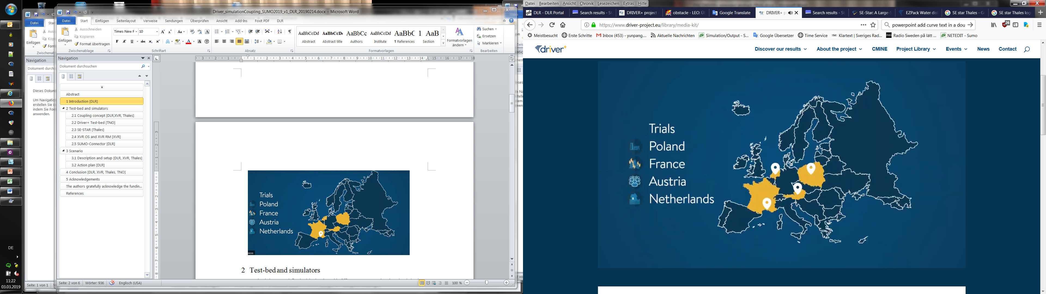

Figure 1 Locations of the trials executed in the Driver+ project

1. Test-bed and simulators

For simulating a pre-defined crisis situation with different aspects together the related simulators communicate and synchronize with each other via the Driver+ test bed Kafka. In the following, Kafka’s framework and its current development status and functions will be introduced. After that, the concept to couple the three simulators, XVR, SE-Star and SUMO, is explained. The main characters and functions of the simulators and the ways to connect them to Kafka are explained accordingly.

* 1. Driver+ Test-bed [TNO]

The Test bed Kafa is an open source test bed.

framework, current development and functions, format…

Figure 2 Overview of the framework of the test bed Kafka (Vullings, 2019).

* 1. Coupling concept [DLR,XVR, Thales]

The main goal of the current coupling work is to carry out a common simulation environment with consideration of vehicles, pedestrians, trainees and real-time vehicle dispatching, routing and positioning. This simulation environment can then be used for crisis trials and exercises.

The whole coupling work is based on the test bed Kafka and illustrated in Figure 3. All simulators are synchronized with the time service provided by the test bed Kafka. There is a trial manager tool in the test bed for request sending and data exchanging. XVR (OS and RM) is used as visualization platform for training and also as request sender. As visualization platform XVR OS continuously indicates crowd movements and interacts with trainees according to the pre-defined training procedure, while XVR RM sends requests for vehicle dispatching, routing or/and positioning. Vehicular positions will be indicated in the XVR RM portal.

On the traffic simulation side, SUMO executes firstly the requests from the trial manager to start the simulation and then to block the defined roads if necessary. During the simulation, SUMO can send vehicles into the simulation with the given positions, search the fastest route for certain vehicles and send back the respective route information, vehicle positions and traffic state according to the requests from XVR RM and the trial manager.

On the crowd simulation side, SE-STAR receives real-time obstacle positions from XVR OS and vehicle positions from SUMO for simulating crowd movements, and delivers crowd positions to XVR OS.

As indicated in Figure 3 the main coupling work is finished. Some of the functions will be implemented in the next phase.

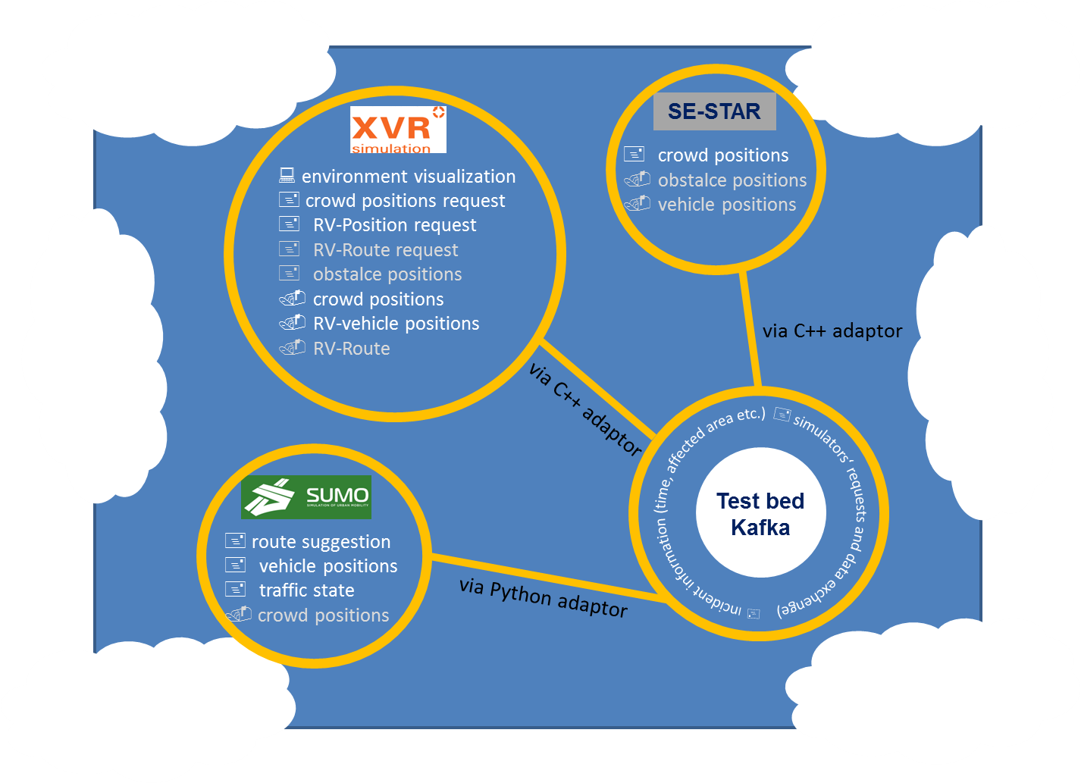

\*: RV: rescue vehicle; \*\*: functions in grey will be implemented in the next step.

Figure 3 The concept to couple XVR, SUMO and SE-Star for a common traffic-related simulation trial

* 1. SE-STAR [Thales]

Inside Data Science & Artificial Intelligence Labs of THALES, we have been designing a Crowd Simulation engine called SE-Star since 2008. SE-Star is a life simulator managing: internal variables, motivations & emotions, stimuli, personality and behaviors. SE-Star uses a Biomimetic control architecture based on navigation (Hippocampus), action selection (Basal ganglia) and planning (Frontal cortex). Use-cases are: design of critical infrastructures and business processes, supervision (video & crowd) operators’ training, data generation for deep neural networks training (video & dataset generation), decision support, what-if scenario exploration and collaborative systems testbed. SE-Star can provide information from high level (density, alarms, situation reports) to low level (individual’s information, devices’ status). SE-Star can simulate between 5000 and 10000 peoples on one computer. SE-Star can work in distributed mode pushing limits (Tested with 80000 peoples on 10 NUC computers). SE-Star has been used in EU project (Opti-Alert, SECURE-Ed, iCore) and in THALES projects covering airports (Pisa), train stations (Gare du Nord) or crowded places (Mecca). Easily extendable, SE-Star has been connected to real systems (crowd monitoring, airport supervision) using standard interfaces and protocols (SAOP, REST, RTSP).

In the Driver+ project, we have decided to use C# test bed adapter. We have extended it to support SE-Star network messages. SE-Star network messages allow to control the simulation, share Entities and Objects information and control them.

* Control the simulation: From the test bed time service, it’s possible to pause, play and change speed of the SE-Star simulation.
* Share Entities and Objects: SE-Star creates entities and objects relevant for the crowd simulation. Objects can be entry points for building (shops, restaurants, main entrances …) or security equipment like speakers for evacuation. SE-Star gets objects and entities that can impact the crowd simulation. It can be vehicles from XVR (ambulances) or SUMO (road traffic and sign) and entities from XVR like a firefighter.
  1. XVR [XVR]
* Brief introduction about XVR OS and XVR RM
* Connectors built for coupling with the test-bed/SE-STAR
* functions
  1. SUMO-Connector [DLR]

To be able to interact with other simulators during a simulation the SUMO component TraCI (Traffic Control Interface) is applied. TraCI can give access to a running road traffic simulation and allows to retrieve values of simulated objects, to manipulate their behaviors on-line and to change the usage status of the infrastructure, e.g. road/lane use and traffic light control (SUMO-TraCI, 2019). Currently, most of TraCI functions are implemented in Python. Therefore, the python-test-bed-adapter is adopted to connect SUMO and the test bed Kafka.

According to the defined coupling concept in 2.2 the required messages are divided into three categories.

* Configuration

In this category, the start and end times of a simulation and the simulation configure file name are defined. Moreover, the data aggregation intervals for the traffic in the whole network, each single vehicle and the traffic in the affected area are defined respectively, where the latter two intervals are optional items. The corresponding data will be sent back to the test bed Kafka at the pre-defined intervals.

* Affected areas

Each affected area is defined with ID, the polygon information and the begin and end times. Furthermore, the status of broken traffic lights, i.e. true or false, and the restricted vehicle type also needs to be defined. All roads in the affected areas will be closed according to the given begin and end times.

* Request

It is mainly to handle the requests (1) to insert rescue vehicles in the simulation with the given geo-coordinates, (2) to find the corresponding fastest routes and send them back to the test bed, and (3) to send the respective vehicle positions at each time stamp, which is configurable, back to the test bed.

Avro schema is used to define the respective data schemas with use of JSON. The developed SUMO-Connector is available under <https://github.com/DRIVER-EU/sumo-connector>.

1. Scenario
   1. Description [DLR]

To test the proposed coupling work a synthetic scenario around the main railway station in Rotterdam, the Netherlanders has been established. In this scenario, a vehicle incident has occurred next to the main railway station. No trains are allowed to run. The surrounding roads need to be closed and the people inside and around the railway station need to be evacuated. An overview about the scenario is illustrated in Figure 4.

Furthermore, the crisis manager needs to send the rescue vehicles from different units to different locations from time to time according to the recuse situation.

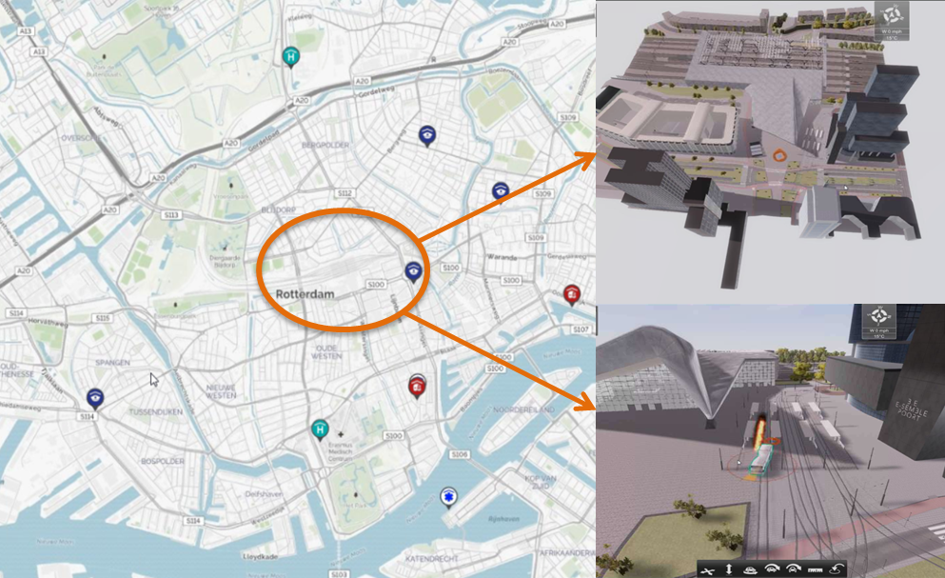

Figure 4 Overview of the synthetic scenario at the main railway station in Rotterdam,.

* 1. Simulation setup

OpenStreetMap is used as the basic map for all simulators. Moreover, the 3D map at the main railway station is also applied for crowd simulation and trial visualization. Regarding traffic demand, synthetic traffic, including passenger cars, buses, trucks, trams, bicycles and pedestrians, is generated. Figure 5 shows an overview about the simulated crowd movements with SE-STAR, while Figure 6 shows the network for traffic simulation and the area of road closure, indicated in yellow. During the road closure period only authority vehicles can run in the closed area. There is no change in traffic light control. Together with the crowd movements, vehicle positions, which are upon request, will be sent to the test bed. XVR will then receive these data and visualize them in the trial simulation environment (XVR OS) and the traffic information portal (XVR RM) accordingly. Figure 7 and illustrates the trial simulation environment with XVR OS.

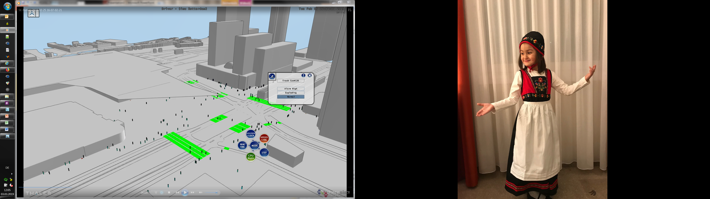

Figure 5 Simulated crowd movements in the Scenario at the main railway station in Rotterdam.

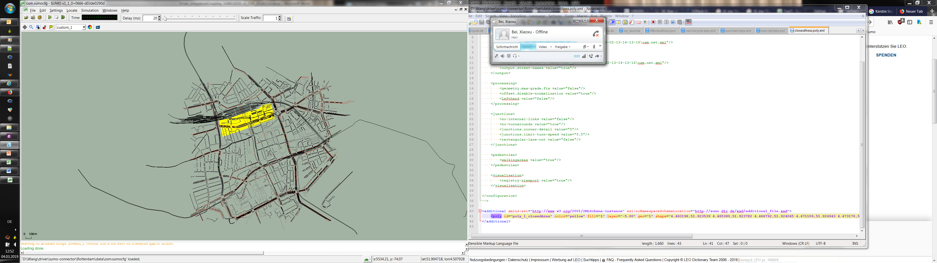

\* All the roads in the yellow area are closed due to the vehicle incident.

Figure 6 Overview of the microscopic traffic simulation network.

Figure 7 Illustration of the trial simulation environment with use of XVR OS.

* 1. Action plan [DLR]

According to the scenario description in 3.1 the corresponding action plan is developed for testing the coupling work. Figure 8 shows the sequence of all actions and the messages needed to be exchanged in the scenario.

Figure 8 Sequence diagram of the proposed actions

1. Conclusion [DLR, XVR, Thales, TNO]

* Limitations of the coupling
* Trial manager tool
* Route search/indication
* Obstacles from XVR to SE-STAR
* Future Work

1. Acknowledgements

The authors gratefully acknowledge the funding of the DRIVER+ project received from the European Union’s 7th Framework Programme for research, technological development and demonstration under Grant Agreement no. 607798.

References

Driver+. (2019). DRIVER+ Objectives and activities. Retrieved 02 28, 2019, from https://www.driver-project.eu/driver-project/objectives-and-activities/

Vullings, Erik, van Campen, S., Hameete, P., Hendriks, M. (2019). Cloud-based M&S for Trails and Exercises. In *2019 30th International Forum for the Military and Civil Simulation, Training and Education Community (ITEC)*, May 14-16, Stockholm. (accepted)

Lopez, P. A., Behrisch, M., Bieker-Walz, L., Erdmann, J., Flötteröd, Y.-P., Hilbrich, R., … Wießner, E. (2018). Microscopic Traffic Simulation using SUMO. In *2018 21st International Conference on Intelligent Transportation Systems (ITSC)* (pp. 2575–2582). IEEE.

SUMO. (2019). *SUMO: TraCI*. Retrieved 02 28, 2019, from https://sumo.dlr.de/wiki/TraCI